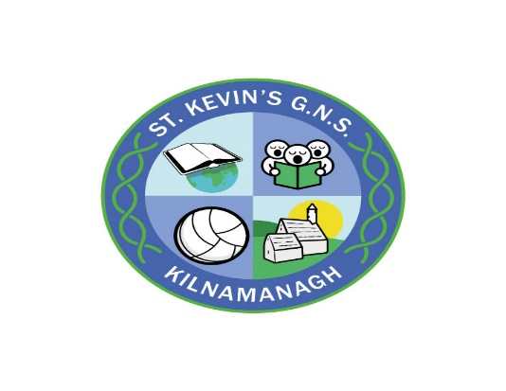
St Kevin’s GNS
Enrolment Form

If you would like assistance in completing this form – please ask. We are happy to help.
CHILD’ S PERSONAL DETAILS:
Child’s first name
Child’s surname
Birth certificate name (if different from above):
Child’s PPS number:
Child’s date of birth: | __ __ / __ __ / __ __ __ __
Place of birth / Country of birth:
Child’s nationality:
Gender: | Female
Mother’s maiden name:

CHILD’S HOME ADDRESS:

PARENT / GUARDIAN CONTACT DETAILS:
Mother’s name:
Mother’s mobile number:
Mother’s alternative contact number:
Mother’s email address:

Father’s name:
Father’s mobile number:
Father’s alternative contact number:
Father’s email address:

Emergency Contact: In the event of an emergency, where neither parent is contactable – please nominate a person to contact / collect your child from school (other than numbers already given)
Emergency contact name:
Relationship to child:
Telephone number:

HISTORY WITH THE SCHOOL:
Does your child have sibling(s) currently attending St Kevin’s GNS or St Kevin’s Boys’ School? | YES / NO
If so, what class is sibling(s) currently in?
Please state sibling(s) name(s):
Has a sibling previously attended St Kevin’s GNS?
If so, please state that child’s name:
Have other family members (mother/aunt) attended the school in the past? If so, please state their names:

FAMILY:
Do both parents have full guardianship of the child you wish to enrol? | YES / NO
Do both parents have the legal right to remove the child from school? | YES / NO
Does your child live at home with both parents? | YES / NO
If no, please detail living/custody arrangements: If there are any legal guardian or custody issues, please inform the school in writing.

MEDICAL HISTORY:
Is your child taking long-term medication? If so, please give details below | YES / NO
Do you have concerns about your child’s health? If so, please give details below | YES / NO
Do you have any concerns in relation to your child’s hearing or eyesight? | YES / NO
Does your child have any known allergies? If so, please give details below | YES / NO
Do you have concerns in relation to your child’s speech and language development? | YES / NO
Do you have concerns in relation to your child’s co-ordination or balance? | YES / NO
Further Details:

PERSONAL DEVELOPMENT
Does your child have good self-care skills? * | YES / NO
*Self-care includes putting on and taking off a coat, using the bathroom alone, opening a school bag/ lunch box or drink unassisted.
Does your child currently use toilet unassisted and do they have the necessary skills needed to independently care for themself? | YES / NO
Is your child generally well behaved with the ability to accept correction? | YES / NO
Does your child have good listening skills? | YES / NO
Did your child progress through pre-school, without concerns being raised by staff? | YES / NO
Which pre-school did you child attend?

Please let us know of any concerns you may have in relation to your child’s learning. We use information given to help your child best progress through their learning programme. In some cases, your child may be entitled to extra support from the Department of Education and Skills based on Speech & Language or Psychological Reports.
Has your child been assessed by a psychologist? | YES / NO
Have you made an application to have your child assessed by a psychologist? | YES / NO
Does your child have any sensory issues? Or do you have any concerns regarding this? | YES / NO
Does your child have any specific special or physical requirements, which may impact on his school day? | YES / NO

Further Details (if answered yes to any of the above questions):

From time to time we celebrate the many different cultural traditions in our school. If you would like to share your cultural background with us please write it below.

Department of Education & Skills Questionnaire
The Department of Education & Skills (DES) has consulted with the Data Protection Commissioner in relation to the collection of individual pupil information for the Primary Online Database (POD). Both religion and ethnic and cultural background are considered sensitive personal data categories under Data Protection legislation. Therefore, it is necessary for each pupil’s parent/guardian to identify their child’s religion and ethnic background, and to consent for this information to be transferred to the DES. All other information held on POD was deemed by the Data Protection Commissioner as non-sensitive personal data.

Please give details of your child’s former school – please tick one
Childcare
Montessori
Home Environment
From abroad
Another school within the state

Is English the main language spoken at home? | YES | NO

To which ethnic or cultural background group does your child belong? Please tick one
*Categories are taken from the Census of Population
White Irish |  | Irish Traveller
Roma |  | Any other white background
Black African |  | Any other black background
Chinese |  | Any other Asian background
Other including mixed background |  | No Consent

What is your child’s religion? Please tick one
Categories are taken from the Census of Population
Roman Catholic |  | Church of Ireland
Methodist, Wesleyan |  | Jewish
Hindu |  | Apostolic or Pentecostal
Other religion |  | No Religion
Lutheran |  | Muslim (Islamic)
Muslim (Islamic) |  | Agnostic
No Consent

I consent for this information to be stored on the Primary Online Database (POD) and transferred to the Department of Education and Skills and any other primary schools my child may transfer to during the course of their time in primary school.

Signed: _______________________ (Parent/Guardian) Date: _______________

DECLARATION:
- I wish to apply for a place for my child at St. Kevin’s GNS.
- I understand that placement is subject to availability and that I will receive written confirmation if this application is successful.
- I understand that there is an enrolment policy which the school will use when considering this application.
- I have been provided with a copy of the school’s enrolment policy.
- I understand that the full details of my child, including details of their religion and racial background will be stored on the schools computer system and passed to the Department of Education and Skills (DES)
- I confirm that the information provided is correct.
- I understand that I must provide the following information in order for my application to be fully considered. Birth Certificate / Baptismal Certificate (if applicable) / Proof of Address.

Signed: ______________________(Parent Guardian) Date: __________________

Signed: ______________________(Parent Guardian) Date: __________________

If this application form is being signed by one parent only please read and sign the following:

I confirm that I am the parent/legal guardian of the child I make this application for.
I confirm that both of his parents are aware of and consent to this enrolment application to St Kevin’s GNS.

Signed: ______________________(Parent Guardian) Date: __________________

For office use only
Date application received: ___ ___ / ___ ___ / ___ ___ ___ ___
Birth cert received: Original returned:
Baptismal cert received: Original returned:
Proof of address: PPS number:
Sibling details checked:

