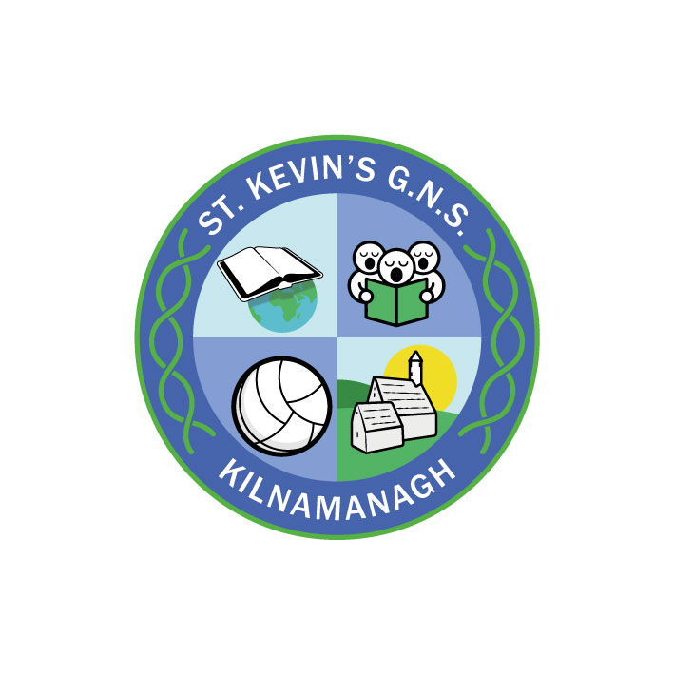
St. Kevin’s G.N.S.

Kilnamanagh, Dublin 24
Telephone: 01-4517981
info@stkevinsgns.com

St. Kevin’s G.N.S.
Kilnamanagh, Dublin 24. Roll no. 19466E
ANNUAL ADMISSION NOTICE
in respect of admissions to the 2024/2025 school year

Admission Policy and Application Form.
A copy of the school’s Admission Policy and the Application Form for Admission for the 2024/2025 school year are available as follows: –
- To download at: www.stkevinsgns.com
- On request:
  - By emailing info@stkevinsgns.com
  - By writing to: St. Kevin’s G.N.S., Treepark Road, Kilnamanagh, Dublin 24.

PART 1 - Admissions to the 2024/2025 school year

Application and Decision Dates for admission to 2024/2025
The following are the dates applicable for admission to Junior Infants

The school will commence accepting applications for admission on | 9th October 2023
The school shall cease accepting applications for admission on | 27th October 2023 @2.30 pm
The date by which applicants will be notified of the decision on their application is | 17th November 2023
The period within which applicants must confirm acceptance of an offer of admission is before | 1st December 2023

*Failure to accept an offer within the prescribed period above may result in the offer being withdrawn

Note: the school will consider and issue decisions on late applications in accordance with the school’s admission policy.

Please note that in the event of over-subscription (more applications than places) children who have not reached four years of age on or before 31st March will have their applications deferred for a year. The following year their parents will need to re-apply on their behalf and the application will be treated as a new application.

Special Class Application and Decision Dates for admission to 2024/2025 school year -
The following are the dates applicable for admission to the school’s Special Class which caters for children with a diagnosis of ASD and a recommendation for placement in a Special Class within a Mainstream school.
The school will commence accepting applications for admission to the special class on | 9th October 2023
The school shall cease accepting applications for admission to the special class on | 23rd February 2024 @ 2.30 pm
The date by which applicants will be notified of the decision on their application for admission to the special class is | 8th March 2024
The period within which applicants must confirm acceptance of an offer of admission is before | 22nd March 2024
*Failure to accept an offer within the prescribed period above may result in the offer being withdrawn

Number of places being made available in St. Kevin’s Boys’ School
The number of places being made available in junior infants is | 28
The number of places being made available in the special class* catering for children with complex educational needs arising from their diagnosis of autism is | Unknown

PART 2 – History of last year - Admissions to the 2022/2023 school year.
In respect of the 2022/2023 school year and applications to Junior Infants
Breakdown of places allocated for the 2022/2023 school year:
Number of places available was | 28
Number of applications received was | 28
Number of Offers made and accepted under each criteria was | All categories offered places – 28 places offered.  24 places accepted.
Total number of offers made | 28
Number of names placed on waiting list for the school year concerned. | 0

In respect of the 2022/2023 school year, the total number of applications for admission received by the school for placement in the special class was 11
Breakdown of places allocated for the 2022/2023 school year:
Number of places available: | 1
Number of applications received: | 12
Number of Offers made and accepted under each criteria: | Category 1 – 2 places offered & accepted
Total number of offers made | 2
Number of names placed on waiting list for the school year concerned. | 11

