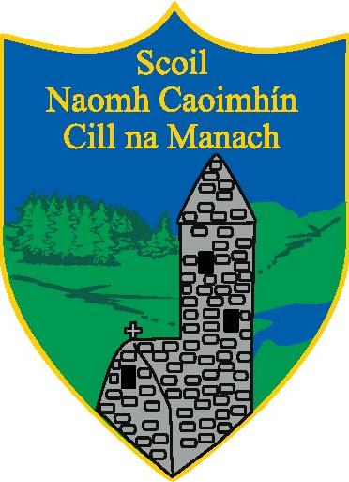
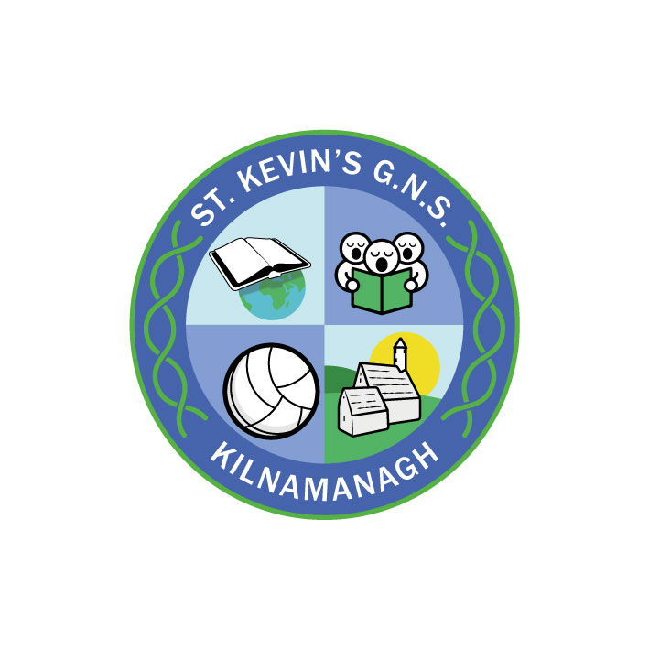
St. Kevin’s Boys’ and Girls’ Schools
Kilnamanagh
Dublin 24

Enrolment for Junior Infant & Special classes September 2024

Enrolment for September 2024 opens on Monday 9th October 2023
- Completed Junior Infant Application forms must be returned to us by 2.30pm on Friday, 27th of October 2023.
- Completed Applications for the Special class must be returned to us before 2.30pm on Friday, 23rd of February 2024.

Admission Policy and Application Forms are available to download on each schools’ website or can be requested by email/post.

Girls’ School Contact details
www.stkevinsgns.com
info@stkevinsgns.com
01-451 7981

Boys’ School Contact details
www.stkevinskilnamanagh.ie
marion@stkevinsboys.ie
01-451 7925

Application forms will be available from Monday, 9^{h} of October on the school website and from the school office.

