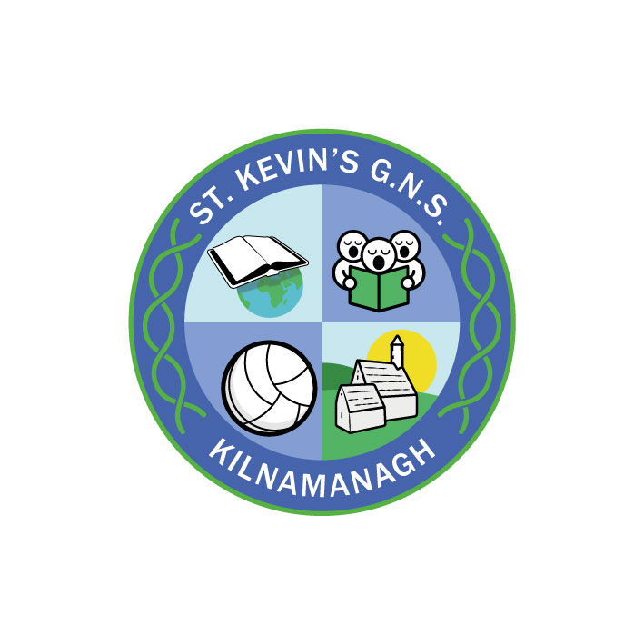
St. Kevin’s G.N.S.

Kilnamanagh, Dublin 24
Roll No.: 19466E
Telephone: 01-4517981
Fax: 01-4526339
info@stkevinsgns.com

St. Kevin’s G.N.S. Communication Policy
- Introduction
Our school has many lines of communication to maintain, including with parents/guardians and carers, with other schools, with the community, with outside agencies and within the school.

We, in St. Kevin’s G.N.S. acknowledge that the parents/guardians are the primary educators of their children, and we endeavour to create an open and welcoming atmosphere, for them and their children. To facilitate an open atmosphere, a variety of methods of communication are in place throughout the school.

We consider good communication between the school and the home to be essential. Children achieve more when schools and parents/guardians work together. Parents/guardians can naturally help more if they know what the school is trying to achieve. Communication between school and home should be open and positive.

- Rationale
This policy was developed
- to ensure communication is open, respectful and positive
- to outline roles and responsibilities
- to assist our school community in providing the optimum learning experiences for our pupils
- to explore how parents/guardians might best support our school and pupils
- to promote and develop home/school partnership in a range of ways
- with reference to DES Circular 24/91 Parents as Partners in Education
- with reference to the Education Act 1998 and the Education Welfare Act 2000.
- Please see our Visitors Code of Conduct

- Relationship to the Ethos of the school
St. Kevin’s G.N.S. is a primary school under the patronage of the Archbishop of Dublin. We aim to ensure that a positive ethos, reflecting Christian attitudes and values, permeates all school activities, with a spirit of caring for every member of the school community.
In St. Kevin’s G.N.S., we aim to have clear and effective communications with all parents/guardians and with the wider community. Effective communication enables us to share our aims and values, through keeping parents/guardians well informed about school life. This reinforces the important role that parents/guardians play in supporting the school.

- Aims & Responsibilities
Our school aims to ensure all communications are:
• Clear
• Concise
• Two-way
• Timely
• Respectful

School
The school will undertake to ensure that:
- Parents/guardians and children have clear lines of communications
- The curriculum is clearly communicated to parents/guardians
- Parents/guardians are informed of forthcoming events within appropriate timelines
- All communications will be treated as confidential within the school context

Parents/Guardians

The parents and guardians will ensure to:

- Read and note the key communications issued by the school
- Raise issues or concerns at the earliest opportunity with the school in the appropriate manner – Please see the school’s Complaints Procedure
- Act on the communication (for example, attending special meeting)

- Forms of Communication
Phone
There is one phone in the main school office. There is a message facility on this phone. Queries are typically answered within three working days. The phone is not available for use by children, unless in exceptional circumstances. Parents/guardians will be contacted by phone in the event of a head injury – as per our First Aid policy, illness or late collection from school. Please do not use the phone to relay messages to your children or for reporting absences. Absences should be updated using the Aladdin Connect app.
Mobile phones
Mobile phones or smart watches are not allowed in St. Kevin’s G.N.S. unless they have received permission from the board of management. Any child who has permission must hand their phones to their teachers every morning, turned off. These are locked away for the day and returned to the child at the end of the day.
This also applies when a substitute teacher is in charge of a class.
Staff are asked not to use their personal phones during the class time, however phones may be on desks in case of emergency. If a call must be taken during the working day, cover should be sought for the class and the teacher should take the call outside the classroom.
Aladdin
We expect all parents/guardians to inform the school of their current e-mail address and mobile phone number to allow us to communicate efficiently. Aladdin is used to send out a variety of information, either to a targeted group, or to all parents. School fees are paid through Aladdin’s e-payments function. Parents/Guardians are asked to update their contact details on Aladdin if they have changed.
Teachers may contact parents/guardians by email on the Aladdin system to arrange an appointment for a meeting specific. They will be provided with a form detailing the reasons for the meeting.
Class updates may be sent using the Aladdin system. Teachers may communicate with the parents/guardians of the children in their classes with details of the work or theme that has been covered in class.

Email
Email is the school’s preferred mode of communication. The office can be contacted at info@stkevinsgns.com.
Class teachers have dedicated work email addresses. These email addresses are mainly used for:
- internal staff communications
- organising field trips and workshops
- accessing the school’s Outlook calendar for planning
All email addresses are available on the school website www.stkevinsgns.com
Parents/guardians are asked not to approach members of staff at the beginning or end of the school day or outside of school time, as this does not allow for confidential discussion and disrupts the timetable. Parents/guardians are asked not to request an immediate meeting with a teacher in the mornings as cover for classes cannot always be provided without notice.
Email communication will be monitored, and we ask that teacher’s time is respected. Teachers cannot read or respond to emails during the working day. Queries are typically answered within three working days.
- In line with our Visitor Code of Conduct we ask that all communication with the school would be respectful.
- Should a phone call become in any way abusive, the call will be terminated.
Arranging a meeting with Teacher
To arrange meetings with individual teachers, parents and guardians are asked to do so through the office at info@stkevinsgns.com.
Arranging a Meeting with the Principal
The School Principal is happy to meet parents/guardians regarding enrolments, finances, secondary schools etc. Please ring the school secretary at 01-4517981 to arrange this.
However, when it comes to a concern or complaint, a parent/guardian must first contact the class teacher regarding the matter via the school office and request a ‘Meeting with Principal Request Form’. If the matter has not been discussed with the class teacher, the parent/guardian will be redirected to do so. If the matter has not been resolved at this stage, the principal will then arrange a time and date on which they are available.

Letters
Letters can be handed into, or posted to, the school office. As with emails, all letters will be treated with full confidentiality and the responses will be made by the member of staff addressed. Please note all letters should specify the member of staff to whom the query is addressed. Please let the office staff know if the letter contains information about your child which you would like the class teacher to receive urgently.
Absence Reporting
Parents and guardians are asked to update the Aladdin app regarding absences. This can be done after the teacher takes the roll call typically after 9.15am. Please do not contact the office or individual class teachers to relay information regarding absences. The school is obliged, for insurance and fire safety purposes, to mark children as late if they are late to school due to an appointment.
School website
Our school website www.stkevinsgns.com contains a range of specific information to give parents/guardians, and the wider public, a full picture of provision at our school. All relevant policies are uploaded to the website. We update our website for each school year.
Specific Information and Events
A calendar of school events and closures will be produced at the start of each term and communicated via the school Newsletter and on the website. It contains general details of school events and activities. We send other letters via email when necessary.
We welcome and value all feedback from parents/guardians about our school’s policies and practices.
From time to time (Covid restrictions permitting) we arrange evening meetings for parents/guardians. These evening meetings may be regarding Safer Internet Usage, Child Protection, Healthy Eating & Nutrition, Resilience & Well-being to mention a few.
We hold a meeting for new parents/guardians each May/June.
Formal Parent Teacher (PT) Meetings
We hold annual Parent Teacher Meetings. Parents/guardians are asked to sign up for these meetings and to arrive on time whether in person or by phone if previously arranged. These meetings are arranged for the afternoon and evening to facilitate parents/guardians. Where possible, it is more effective for parents/guardians to attend the consultation together so that a common approach to supporting the child in their learning can be agreed. If exceptional circumstance means this is not possible, we will try to arrange separate meetings.
The purpose of Parent/Teacher meetings is to:
• Let parents/guardians know how their children are progressing in school
• Establish an on-going relationship and communication with
parents/guardians
• To help children realise that home and school are working together
• To share children’s strengths and abilities with the parents
• To review with the parent the child’s experience of schooling
• To identify ways in which parents/guardians, and teachers can support the child further
Standardised Tests & Written Reports
In the summer term, parents/guardians receive a report with details of the child’s attainment and progress across the curriculum and their attitude to learning. These are released to parents/guardians using the Aladdin app.
Following the completion of standardised testing in May, parents/guardians are provided with the opportunity to briefly meet with the class teacher if they have any concerns.
Support Plans
There may be additional meetings arranged with parents/guardians of children who may have additional needs.
Newsletters
The school sends a termly Newsletter to all families via email, highlighting some of the work and achievements that have taken place throughout the term. These newsletters are posted on our website.
Board of Management
Members of the Board of Management are volunteers who work as a collective group and can be contacted via their email address boardofmanagement@stkevinsgns.com or written communications left at the school office and will be forwarded to the Chairperson. All correspondence received is discussed at meetings. Board of Management members must not be contacted individually regarding school matters.
Communication with the Community
Members of the local community are invited to school functions such as Special Assemblies, Graduation, Christmas Carol services, school productions, fundraising events. Quizzes etc.
Guest speakers from local churches, community organisations and charities come into school to speak to the children.
Grievance (Complaints) Procedure for Parents/Guardians
The school’s Grievance Procedure sets out clear guidelines for parents/guardians to follow. This is available on the school’s website or by request from the office.
Communications unrelated to official school business e.g. social media.
Parent/guardian ‘WhatsApp’ groups have become increasingly popular in recent years. Similarly, many parents/guardians are on social media sites and communicate with each other regarding their children. Groups of this nature are not for official school business and are usually used by parents/guardians to arrange parties and playdates etc. It must be noted that all parents have a responsibility to act in a respectful manner. We remind parents/ guardians that if they have a complaint/ issue they should follow the Grievance Procedure Policy. We also remind parents/ guardians that information/ photos about children should not be shared on any social media. The names of any staff member should never be shared on social media.
We recommend not using the class WhatsApp or other Social Media groups to
- support or canvas for a political cause,
- post comments about teachers and members of staff, whether positive or negative,
- post comments about any parents or students in the school
A number of things should be kept in mind when posting on Whatsapp:
- Remember that your post will be seen by approximately 60 people and that children in the school may inadvertently view these also.
- Always use respectful language in your post- if you would not be comfortable posting it on the school wall with your name under it, it may not be suitable to send.
- Consider alternative methods of communication such as email for sharing information on external events etc.

Communication within our school
So that all staff know what is going on, there is a timetable and a whiteboard in the staff room. We also communicate by Microsoft ‘Teams’, Outlook and regular staff meetings.
Written communications with members of staff are hand delivered or forwarded by email.
Staff members' personal details will not be shared with other members of staff or persons external to the school, without due authority.
Communication with other external Educational Organisations
The school regularly communicates with staff and children of other primary schools. Such communication may be by means of personal contact with specific staff or through more formal contact such as cluster groups and by means of sports fixtures and other inter-school events.
Other groups with which we communicate are:
St. Kevin’s Boys’ School, Local pre-schools, ABACAS, the parish team, Family Resource Centre, Credit Union, Active Schools Flag, PDST, School Inclusion Model.
The Principal and Deputy Principal are members of the IPPN (Irish Primary Principal’s Network). Many teachers are members of the INTO Union and many SNAs are members of FORSA union.
Communication with the local secondary schools is predominantly for Sixth Class children. The Education Passports formulated by the NCCA are passed on to relevant Secondary schools before the children move. We also communicate with other schools if a pupil joins mid-year, or leaves St. Kevin’s G.N.S. for another school.
Communication with Outside Agencies
Close contacts are maintained with support agencies including National Educational Psychologists Service (NEPs), the National Council for Special Education (NCSE), TUSLA, the Library Service, the Education Welfare Officer, the Schools Dental Service and the Public Health Nurse. The school always supports contacts with specialists such as occupational therapists and speech and language therapists, clinical psychologists and educational psychologists.
- Success Criteria
- Communication is clear and effective for all
- Positive experiences for all school stakeholders
- Teacher/Parent or Guardian Satisfaction

- Review & Evaluation
This policy will be regularly monitored and will be reviewed every three years or sooner if required.
This Policy was updated and ratified by the Board of Management on 29th November 2022
Signed: 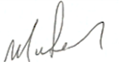(Chairperson, St. Kevin’s G.N.S.)

