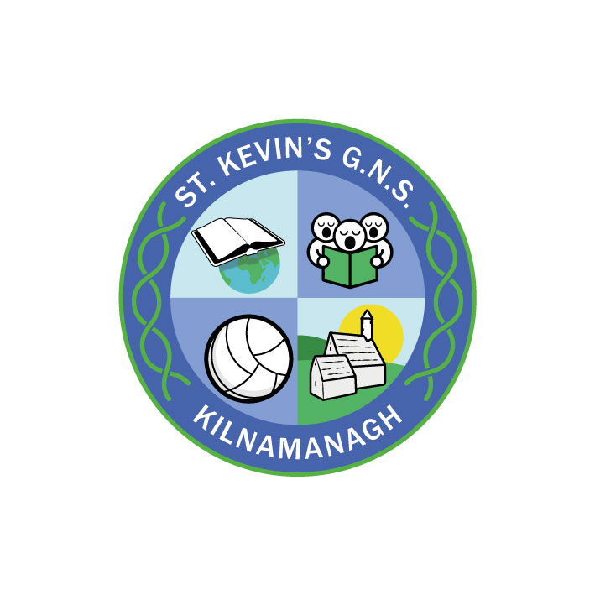
St. Kevin’s G.N.S.

Kilnamanagh, Dublin 24
Roll No.: 19466E
Telephone: 01-4517981
Fax: 01-4526339
www.stkevinsgns.com
info@stkevinsgns.com

Third Class: School Book List 2022/2023
English |  | A First Dictionary | Nisbet
 |  | Ready to Write E1 | Edco
Maths |  | Busy at Maths 3 | C.J. Fallon
 |  | New Wave Mental Maths 3rd Class | Prim Ed.
Stationery | - A 4 Refill Pad  - Mindfulness colouring book of your choice  - 1 A4 Hardback Copybook. (Genre copy; retain from last year).  - 2 Maths copies. 10 no: 11 Copies (88 page)  - 2 A4 zip mesh wallets  - 2 Scrapbooks  - 1 Manuscript copy books 120 pages (ruled)  Pen, pencils, sharpener, rubber, 30cm ruler, red biro, colouring pencils, marker, pritt stick, scissors, whiteboard markers.  (These items should be replaced when necessary throughout the year).

Spellings | Retain from last year
Handwriting | Retain from last year
English | Rented from school
Gaeilge | Rented from school
Readers | Rented from school
Religion | Rented from school
History | Rented from school
Geography | Rented from school
Science | Rented from school
Rental & Sundries | The following expenses arise each year and allow us to run a rental scheme and implement the full curriculum.  Please pay before Friday 9th September.  This may be paid in instalments if you contact the school.  Rental of Books €22.00  Photocopying €16.00  Art & Craft €16.00  Equipment €10.00  ICT €5.00  Helping Hands anti-bullying programme €3.00  Insurance (24 hour cover) €7.00  Total € 79.00

