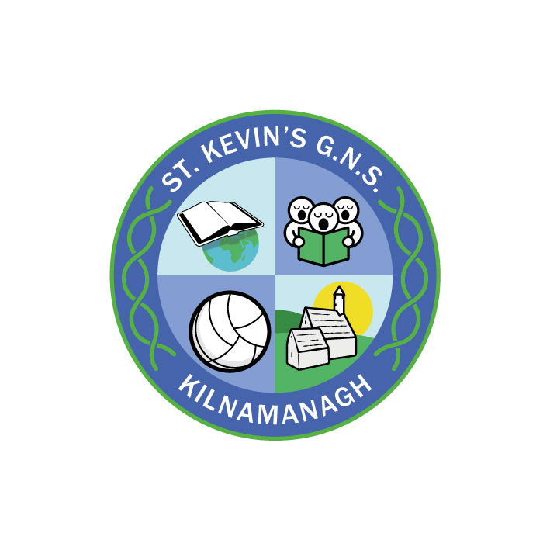
St. Kevin’s G.N.S.

Kilnamanagh, Dublin 24
Roll No.: 19466E
Telephone: 01-4517981
Fax: 01-4526339
www.stkevinsgns.com
info@stkevinsgns.com
______________________________________________________________________________________________________
Sixth Class: School Booklist 2022-2023
Gaeilge | Bua na Cainte 6 | Folens
English | Read at Home 6 New Edition | (C.J.Fallon)
 | Dictionary (Keep from last year).
Maths | New Wave Mental Maths 6 (Revised Ed.) | (Prim Ed)
 | Busy at Maths 6 | (C J Fallon)
SESE | Atlas (from last year)
SPHE | Weaving Wellbeing 6th Class Pupil Book: Empowering Beliefs | Outside the Box
Stationery | - 4X Manuscript Books ASE 4 120 page – ruled with margin.  - 3 X A4 Hardback Copybook  - 8 X 88 page copies (with margin)  - 2 X Maths copies (88 pages)  - Copy Covers  - A4 Display Folder – Minimum 20 plastic pockets  - A4 Refill Pad  - Geometry Set  - 2 X Scrapbooks A4 Size – with coloured pages – available in Bookstation.  - 2 X A4 mesh folders  Calculator, pencils, sharpener, rubber, 2 red biros, 2 blue biros, whiteboard markers and wiper/cloth, colouring pencils or Twistables, markers, pritt stick, scissors (these items should be replaced as needed.)

Rental & Sundries | The following expenses arise each year and allow us to run a rental scheme and implement the full curriculum.  Please pay before Friday 9th September.  This may be paid in instalments if you contact the school.  Rental of Books €20.00 * Photocopying €16.00  Art & Craft €16.00  Equipment €10.00  Helping Hands (Anti-bullying programme) € 3.00  ICT Resources € 5.00  Insurance (24 hour cover) € 7.00  Total: €77.00  *If your daughter is donating her ‘Bua na Cainte 5’ to the school please pay a reduced rate of €15 for your rental which will reduce your total to €72

