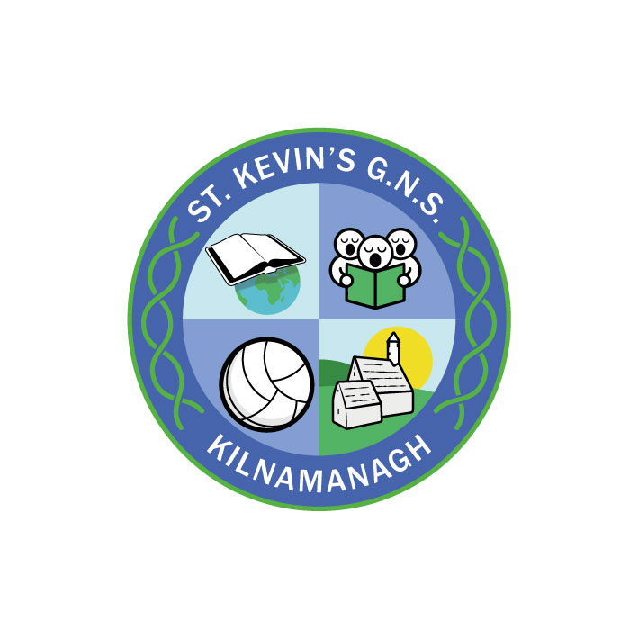
St. Kevin’s G.N.S.

Kilnamanagh, Dublin 24
Roll No.: 19466E
Telephone: 01-4517981
Fax: 01-4526339
www.stkevinsgns.com
info@stkevinsgns.com

Senior Infants: School Booklist 2022/2023
Gaeilge | Bua na Cainte B | Edco
Maths | Busy at Maths | C.J. Fallon
Religion | Grow in Love Senior Infants | Veritas
Handwriting | Ready to Write B1 | Edco
SPHE | Mindful Matters B | C.J. Fallon
SESE | Let’s Discover! | C.J. Fallon
Rental & Sundries | The following expenses arise each year and allow us to run a rental scheme and implement the full curriculum.  Please pay before Friday 10th September.  This may be paid in instalments if you contact the school.  Jolly Phonics Resources €10.00  Rental of Books €12.00  Photocopying €16.00  Art & Craft €16.00  Equipment € 5.00  Stationery €10.00  Insurance (24 hour cover) € 7.00  ICT € 5.00  Total: € 81.00

Please cover and label all books. Please write your daughter’s name clearly on the front cover.

