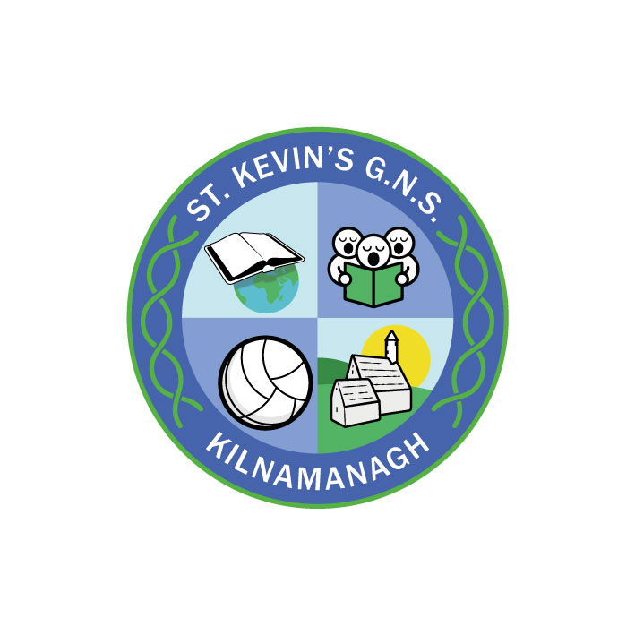
St. Kevin’s G.N.S.

Kilnamanagh, Dublin 24
Roll No.: 19466E
Telephone: 01-4517981
Fax: 01-4526339
www.stkevinsgns.com
info@stkevinsgns.com
Second Class: School Booklist 2022/2023
To be bought
English | Revised Spelling and Tables | Folens
 | Ready to Write D1 | Edco
 | Jolly Grammar Pupil Book 2
Maths | Busy at Maths 2 | C.J. Fallon
 | New Wave Mental Maths 2 | Prim Ed.
Gaeilge | Bua na Cainte 2 | Edco
Religion | Grow in Love - Primary 4 (Second Class) | Veritas
SESE | Let’s Discover! | C.J. Fallon
SPHE | Weaving Wellbeing Pupil Book Second Class
Stationery | - 1 mindfulness colouring book (of choice)  - 1 Maths Copy C3 88 pages  - 1 A4 Manuscript Book 120 pages  - 8 No. 11 copies 88 pages (additional copies may be needed during the year)  - 2 Mesh Bag Folders with zip  Pencil case, pencils, parer, rubber, ruler, red biro, colouring pencils, Pritt Stick, scissors, whiteboard marker and eraser/ cloth  N.B. * These Items should be replaced when necessary during the year.  (See Sundries/Rental below)

Readers | Rented from school
English Literacy Programme | Oral Language and Jolly Learning Programmes rented from school
SESE | Supplementary reading materials rented from school
Rental & Sundries | The following expenses arise each year and allow us to run a rental scheme and implement the full curriculum. This money is not payable until the end of September, however families have the option to pay over the summer.  Rental of Books €10.00  Photocopying €16.00  Art & Craft €16.00  Equipment & Library €20.00  ICT & maintenance € 5.00  Helping Hands Programme € 3.00  Insurance (24 hour cover) € 7.00  Total € 77.00

