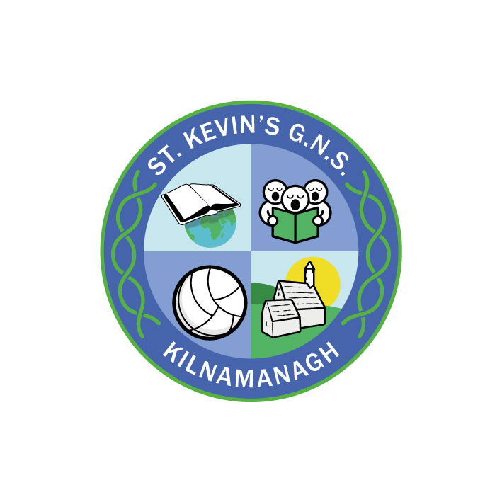
St. Kevin’s G.N.S.

Kilnamanagh, Dublin 24
Roll No.: 19466E
Telephone: 01-4517981
Fax: 01-4526339
www.stkevinsgns.com
info@stkevinsgns.com
Fourth Class: School Book List 2022/2023
To be bought
English |  | Read at Home Book 4 (New Edition)  Ready to write F1 (in cursive) | C.J Fallon  Edco
Maths |  | Busy at Maths 4  New Wave Mental Maths 4th Class | C.J. Fallon  Prim Ed.
SPHE |  | Weaving Wellbeing Fourth Class: Tools of Resilience  Mindfulness colouring book of your choice | Outside the box
Stationery | - A 4 Refill Pad  - 1 A4 Hardback Copybook. (Genre copy; retain from last year).  - 1 Maths copy  - 8 (Number 11) copies 88 pages  - 2 A4 zip mesh wallets  - 2 Scrapbooks  - 2 Manuscript copy books 120 pages (ruled)  Pen, pencils, sharpener, rubber, 30cm ruler, red biro, colouring pencils, marker, pritt stick, scissors, whiteboard markers.  (These items should be replaced when necessary throughout the year).

English | A first dictionary (retain from last year)
Spellings | Retain from last year
Gaeilge | Rented from school
Readers | Rented from school
Religion | Rented from school
History | Rented from school
Geography | Rented from school
Science | Rented from school
Rental & Sundries | The following expenses arise each year and allow us to run a rental scheme and implement the full curriculum. This money is not payable until the end of September, however families have had the option to pay over the summer.  Rental of Books €22.00  Photocopying €16.00  Art & Craft €16.00  ICT €5.00  Equipment €10.00  Helping Hands anti-bullying  Programme € 3.00  Insurance (24 hour cover) € 7.00  Total € 79.00

