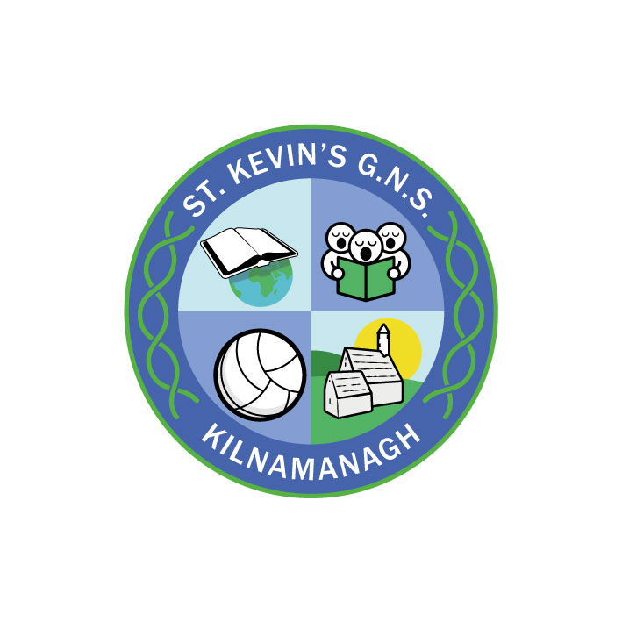
St. Kevin’s G.N.S.

Kilnamanagh, Dublin 24
Roll No.: 19466E
Telephone: 01-4517981
Fax: 01-4526339
www.stkevinsgns.com
info@stkevinsgns.com
First Class: School Booklist 2022/2023
To be bought
English | Ready to Write C1 (Cursive) First Class | EdCo
 | Spellbound 1 First Class (published by CJ Fallon) | C.J. Fallon
 | Jolly Grammar Pupil Book 1
Maths | Busy at Maths 1 | C.J. Fallon
Gaeilge | Bua na Cainte 1 | EdCo
Religion | Grow in Love - Primary 3 (First Class) | Veritas
SESE | Let’s Discover! | C.J. Fallon
SPHE | Mindful Matters 1 | C.J. Fallon

Readers | Rented from school
English Literacy Programme | Rainbow Oral Language and Jolly Learning Programmes rented from school
SESE | Supplementary reading materials rented from school
Rental & Sundries | The following expenses arise each year and allow us to run a rental scheme and implement the full curriculum.  Please pay before Friday 9th September 2022.  This may be paid in instalments if you contact the school.  Rental of Books €12.00  Photocopying €16.00  Art & Craft €16.00  Equipment €10.00  Stationery (bought by teacher) € 10.00  ICT & maintenance € 5.00  Helping Hands Programme € 3.00  Insurance (24 hour cover) € 7.00  Total € 79.00
First Class will finish at 1.30p.m. until Friday 16th September.
Monday 19th September will be a full day.

