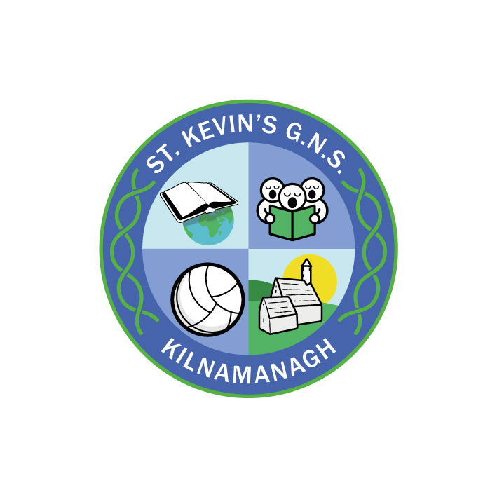
St. Kevin’s G.N.S.

Kilnamanagh, Dublin 24
Roll No.: 19466E
Telephone: 01-4517981
Fax: 01-4526339
www.stkevinsgns.com
info@stkevinsgns.com
Fifth Class: School Book List 2022/2023
English |  | Read at Home Book 5 (New edition) | C.J. Fallon
Gaeilge |  | Bua na Cainte 5 | Edco
Maths |  | Busy at Maths 5 | C.J. Fallon
 |  | New Wave Mental Maths 5th Class | Prim Ed.
SPHE |  | Weaving Wellbeing Fifth Class Positive Relationships | Outside the box
Stationery | - 2 X 32 page Memorandum Books ASBM ruled with margin.  - 2 Maths Copies.  - Geometry Set  - A 4 Refill Pad.  - 10 no: 11 Copies (88 page).  - 2 Document Holders which holds at least 40 plastic envelopes.  - 3 Manuscript Books ASE4 120 pages  - Geometry Set.  - 2 Scrapbooks.  - Mindfulness Colouring Book  Pencils, pens, sharpener, rubber, 30cm ruler, red biro, colouring pencils or Twistables, markers, pritt-stick, scissors, calculator, white board marker. (These items should be replaced when necessary throughout the year).

English | A First Dictionary (from last year)
Spellings | Revised Spelling & Table Book (from last year)
Readers | Rented from school
Religion | Rented from school
History | Rented from school
Geography | Rented from school
Science | Rented from school
Rental & Sundries | The following expenses arise each year and allow us to run a rental scheme and implement the full curriculum.  Please pay before Friday 10th September.  This may be paid in instalments if you contact the school.  Rental of Books €22.00  Photocopying €16.00  Art & Craft €16.00  Equipment €10.00  ICT € 5.00  Helping Hands anti-bullying programme € 3.00  Insurance (24 hour cover) € 7.00  Total € 79.00

