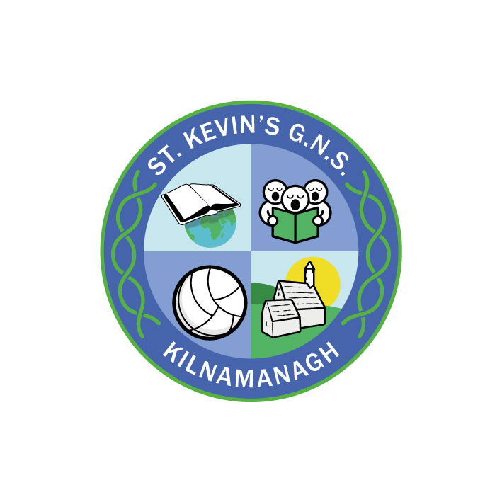
St. Kevin’s G.N.S.

Kilnamanagh, Dublin 24
Roll No.: 19466E
Telephone: 01-4517981
Fax: 01-4526339
info@stkevinsgns.com

St. Kevin’s G.N.S.
ANNUAL ADMISSION NOTICE
in respect of admissions to the 2022/2023 school year
-
Admission Policy and Application Form
A copy of the school’s Admission Policy and the Application Form for Admission for the 2022/2023 is available as follows: –
To download at: www.stkevinsgns.com
On request: By emailing info@stkevinsgns.com or writing to: St. Kevin’s G.N.S., Treepark Rd., Kilnamanagh, Dublin 24

PART 1 - Admissions to the 2022/2023 school year

Application and Decision Dates for admission to St. Kevin’s G.N.S.
The following are the dates applicable for admission to Junior Infants.

The school will commence accepting applications for admission on | 18th October 2021
The school shall cease accepting applications for admission on | 8th November 2021 at 2.30
The date by which applicants will be notified of the decision on their application is Friday 27th November. | 26th November 2021
The period within which applicants must confirm acceptance of an offer of admission is 21 days. | Final date:10th December 2021
*Failure to accept an offer within the prescribed period above may result in the offer being withdrawn

Please note that in the event of over-subscription (more applications than places), preference will be given to older children within a category.

The following year their parents will need to re-apply on their behalf and the application will be treated as a new application.

Note: the school will consider and issue decisions on late applications in accordance with the school’s admission policy.

Special Class Application and Decision Dates for admission to St. Kevin’s G.N.S. 2022/2023
The following are the dates applicable for admission to the school’s Special Class which caters for children with a diagnosis of ASD who have been recommended for placement in a Special Class.
The school will commence accepting applications for admission to the special class on | 18thOctober 2021
The school shall cease accepting applications for admission to the special class on | 4th March 2022 at 2.30
The date by which applicants will be notified of the decision on their application for admission to the special class is | 18th March 2022
The period within which applicants must confirm acceptance of an offer of admission is within three weeks of an offer of a place. | Final date 8th April 2022
*Failure to accept an offer within the prescribed period above may result in the offer being withdrawn

Number of places being made available in September 2022

The number of places being made available in junior infants is | 60
The number of places being made available in the special class catering for children with ASD who have been recommended for placement in an ASD class in a mainstream school is | 0
PART 2 - Admissions to the 2021/2022 school year.
In respect of the 2021/2022 school year
Breakdown of places allocated for the 2021/2022 school year:
Number of places available: | 29
Number of applications received: | 36
Number of Offers made and accepted under each criteria: | Category 1 & Category 2 –. (29)  Category 3 –
Total number of offers made | 30
Number of names placed on waiting list for the school year concerned. | 6

In respect of the 2020/2021 school year, the total number of applications for admission received by the school for placement in the special class was 7e
Breakdown of places allocated for the 2020/2021 school year:
Number of places available: | 0
Number of applications received: | 12
Number of Offers made and accepted under each criteria: | Category 1 & Category 2 –  Category 3 –
Total number of offers made | 0
Number of names placed on waiting list for the school year concerned. | 12

