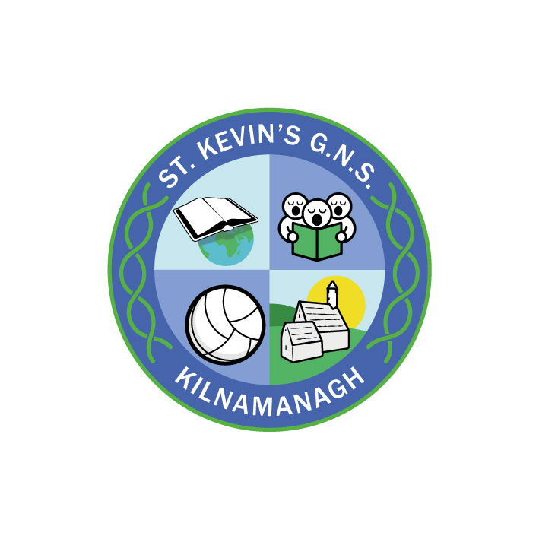
St. Kevin’s G.N.S.

Kilnamanagh, Dublin 24
Roll No.: 19466E
Telephone: 01-4517981
Fax: 01-4526339
info@stkevinsgns.com

St. Kevin’s G.N.S.
ANNUAL ADMISSION NOTICE
in respect of admissions to the 2021/2022 school year
-
Admission Policy and Application Form
A copy of the school’s Admission Policy and the Application Form for Admission for the 2021/2022 is available as follows: –
To download at: www.stkevinsgns.com
On request: By emailing info@stkevinsgns.com or writing to: St. Kevin’s G.N.S., Treepark Rd., Kilnamanagh, Dublin 24

PART 1 - Admissions to the 2021/2022 school year

Application and Decision Dates for admission to St. Kevin’s G.N.S.
The following are the dates applicable for admission to Junior Infants.

The school will commence accepting applications for admission on | 19th October 2020
The school shall cease accepting applications for admission on | 9th November 2020 at 2.30
The date by which applicants will be notified of the decision on their application is Friday 27th November. | 27th November 2020
The period within which applicants must confirm acceptance of an offer of admission is 21 days. | Final date:11thDecember 2020
*Failure to accept an offer within the prescribed period above may result in the offer being withdrawn

Please note that in the event of over-subscription (more applications than places) children who have not reached four years of age on or before 31st March will have their applications deferred for a year. The following year their parents will need to re-apply on their behalf and the application will be treated as a new application.

Note: the school will consider and issue decisions on late applications in accordance with the school’s admission policy.

Special Class Application and Decision Dates for admission to St. Kevin’s G.N.S. 2021/2022
The following are the dates applicable for admission to the school’s Special Class which caters for children with a diagnosis of ASD who have been recommended for placement in a Special Class.
The school will commence accepting applications for admission to the special class on | 19th October 2020
The school shall cease accepting applications for admission to the special class on | 5th March 2021 at 2.30
The date by which applicants will be notified of the decision on their application for admission to the special class is | 26th March 2021
The period within which applicants must confirm acceptance of an offer of admission is within three weeks of an offer of a place. | Final date 16th April 2021
*Failure to accept an offer within the prescribed period above may result in the offer being withdrawn

Number of places being made available in September 2021

The number of places being made available in junior infants is | 29
The number of places being made available in the special class catering for children with ASD who have been recommended for placement in an ASD class in a mainstream school is | 0

