The Second World War Revision Sheet for Sixth Class

Here are some points about the main events, people and facts associated with the war. It will help you to prepare for Friday's quiz as will reading back over the WW2 vocabulary we posted on the school website before Easter.
- The war broke out in 1939 and finished six years later in 1945
- Eamonn de Valera was the Taoiseach and he kept Ireland neutral during the war
- The war years in Ireland were known as The Emergency
- The Treaty of Versailles was one of the main causes of the war as the German people felt it unfairly blamed and penalised them for the first world war
- Many Germans including Hitler also blamed the Jews for their economic difficulties
- Hitler was very anti-Jewish which is also known as being anti-semitic
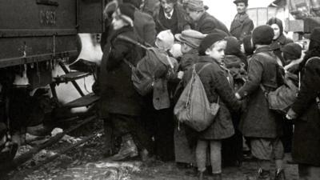
- Adolf Hitler rose to power in Germany with the Nazi Party and quickly rounded up anyone who opposed him. He became the chancellor in 1933 and soon declared himself to be the Fuhrer or leader
- Many children especially Jewish children were rescued from Nazi Europe in an operation known as The Kindertransport
- Hitler wanted to expand Germany‘s control over the rest of Europe and he began by taking over Austria in 1938 in an event known as the Anschluss
- Next the Germans invaded Czechoslovakia and Poland in 1939
- The Nazis developed a new battle strategy called Blitzkreig which meant they invaded another country at lightning speed, knocking out all the communications, power lines, transport links and military bases
- By May 1940, Hitler’s army had invaded Denmark, Holland , Belgium, Norway and France
- The British tried to help the French but they were quickly beaten back to the French coast
- British troops were rescued by the navy and hundreds of volunteers who sailed to Dunkirk in France in pleasure boats and fishing trawlers. The mass evacuation was commemorated in the film Dunkirk
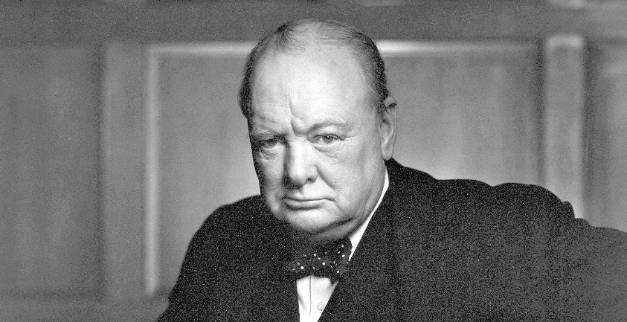
- The British Prime Minister Winston Churchill made many famous speech to help boost the British people including this famous quote; “We shall fight them on the beaches...,we shall fight them in the fields and in the streets.”

- In June 1940 the German air force or Luftwaffe began attacking British cities. The British called the sustained bombing of cities for 57 consecutive days The Blitz
- Food had to be rationed and children were evacuated to the countryside
- Eight countries sided with Germany including Italy and Japan; they became known as The Axis Powers
- When Japan attacked the U.S naval base at Pearl Harbour in Hawaii in 1941, President Franklin D. Roosevelt declared war on the Axis countries
- Governments used propaganda to influence people. Slogans on posters were designed to change behaviour e.g. “Loose lips sink ships”, “Dig for victory”
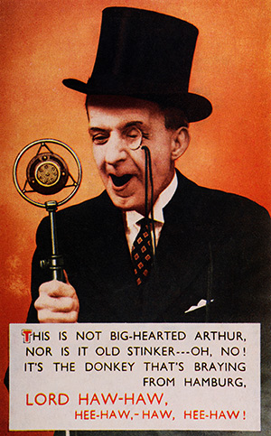
- William Joyce was better known as Lord Haw Haw. He broadcast German propaganda in English during the war

- The allied troops landed on the beaches of Normandy on the 6th June 1944 to invade Nazi Europe in an event known as Deliverance Day or “D-Day”
- The Germans resisted well but by the 8th May 1945 the war in Europe ended when the Germans surrendered; this day is now known as VE Day to celebrate victory in Europe
- The allies called on Japan to surrender but they refused so the Americans developed and dropped two new lethal bombs called the atomic bombs on Japan.
- The Japanese surrendered on 2nd September 1945. World War 2 was finally over
- Trials of leading Nazis were held in the German city of Nuremberg
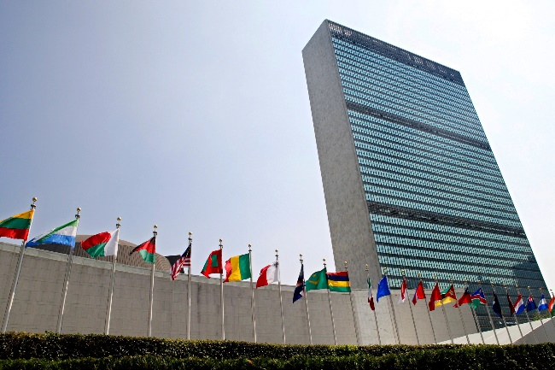
- The United Nations was established to solve problems between countries by working together through peaceful means

- Because of the dramatic nature of life during the war, many novels have been set against the backdrop of the war including “The Boy in the Striped Pyjamas” by John Boyne
