European Geography
Europe is the second smallest continent in size but the third largest in terms of population. It is a very densely populated continent. It consists of fifty countries of which twenty-seven are members of the European Union (E.U). Britain is currently leaving the E.U. in a long -running event which has become known as Brexit.. Russia is the largest European country and Vatican City is the smallest. Reykjavik ,the capital of Iceland , is the most northerly capital city. Norway has the longest coastline in Europe. Cabo da Roca in Portugal is the most westerly point in Europe.

Wildlife
Europe has many different habitats and is home to a wide diversity of wildlife including brown bears ,polar bears wolves , bison and large cats such as lynx and the European wildcat. There are many bird species but none are as striking as the golden eagle which has begun to increase in numbers again . Europe is also home to many reptile species such as lizards and snakes .

Climate
The north of Europe lies in the Arctic Circle and is cold and snowy. The seas around Norway, Scotland and Ireland are kept from freezing during the winter by a current of warm water called the North Atlantic Drift, which travels from the Gulf of Mexico.
Much of the South of Europe lies on the Mediterranean Sea. It has hot summers and mild winters.

Nicknames for Cities and Countries
Land of Fire and Ice | Iceland
The Boot | Italy
Land of a Thousand Lakes | Finland
Land of the Midnight Sun | Norway
Bride of the Sea | Venice
Eternal City | Rome
Venice of the North | Amsterdam
City of Light | Paris

Spotlight on Russia
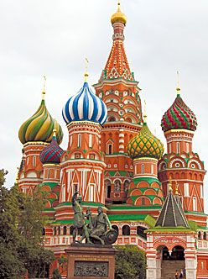
Russia is Europe’s largest country and is home to some of Europe’s leading geographical features including :
- Longest river: Volga 3,531km
The river Volga flows into the Caspian Sea. Mt Elbrus is in the Caucasus Mountains which stretch between the Caspian and the Black Sea

- Highest Mountain: Elbrus 5,642m

- Largest lake in Europe: Lake Ladoga

Russia stretches across the continents of Europe and Asia.
The world’s largest lake is the Caspian Sea which is in Russia and lies between the
two continents. Lake Baikal is the world’s deepest lake and it is located in the Asian
part of Russia .

The River Danube
- Europe’s second longest river
- Commercially , the Danube is an important waterway
- It flows from Germany into Austria, Slovakia, Hungary, Croatia, Serbia, Romania, Bulgaria, Moldova and finally entering the Black Sea in the Ukraine
- On its journey it flows through four European capital cities: Vienna, Bratislava, Budapest and Belgrade

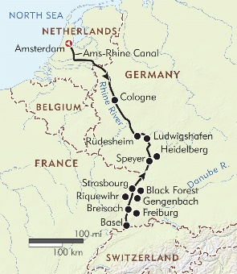
The River Rhine
Europe’s most important river in terms of its role in providing transport links. It serves as a highway for Europe’s goods or freight.
It has its source in Switzerland and flows through/along the borders of Lichtenstein, Austria, Germany, France and the Netherlands where it enters the North Sea.

Mediterranean Islands
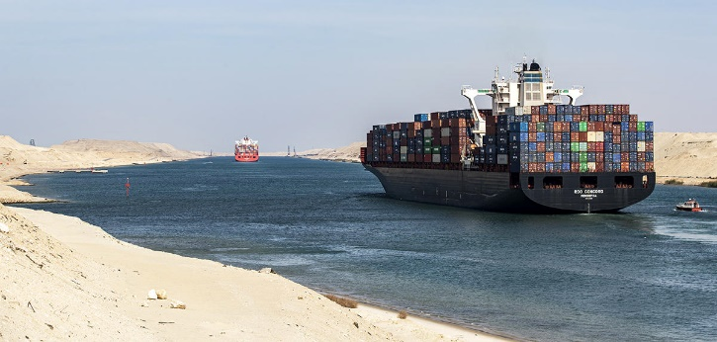
Countries touching the Mediterranean Sea are steeped in history. Great civilisations such as the Romans and the Greeks, come from this area. They had a huge influence on the architecture, art and culture of Europe and the wider world.
For many hundred of years, the Mediterranean Sea has been very important for shipping and trade. The Suez Canal, linking the Mediterranean Sea and Red Sea, was opened in 1869 and this made it much easier to travel to Europe from places such as China and India. Ships have to pass through the Straits of Gibraltar to get from the Mediterranean Sea to the Atlantic Ocean. The largest islands are listed below, starting from the largest (Sicily):
Sicily | Italy
Sardinia | Italy
Cyprus | Cyprus
Corsica | France
Crete | Greece
Euboea | Greece
Majorca | Spain (Balearic Islands)

The Alps
The Alps are the highest and most extensive mountain rang that lie entirely within Europe. They stretch approximately 1,200 km across eight Alpine countries France, Switzerland, Monaco, Italy, Liechtenstein, Austria, Germany and Slovenia. The highest peak in the Alps is Mont Blanc on the border between France and Italy .It stands at 4,808 m above sea level.

Landlocked Countries
A country which has no coastline is known as a landlocked country. Examples include Switzerland, Austria, Hungary and Slovakia. If a landlocked country is surrounded by only landlocked countries it is considered to be a “double landlocked” country; Liechtenstein is one of only two such countries in the world.

Earthquakes
Earthquakes occur around the globe all the time but most are unnoticed by local populations are they are very weak. However some European countries like Italy, Iceland and Greece have all experience devastating earthquakes in their histories.

Volcanoes
- As you all know there are three types of volcanoes: active, dormant and extinct
- Many experts claim that an active volcano is one that has at least one eruption in the last 10,00 years
- There are approx. 60 volcanos that are categorised as active in Europe presently
- However the major volcanoes are the three volcanoes located in Italy:
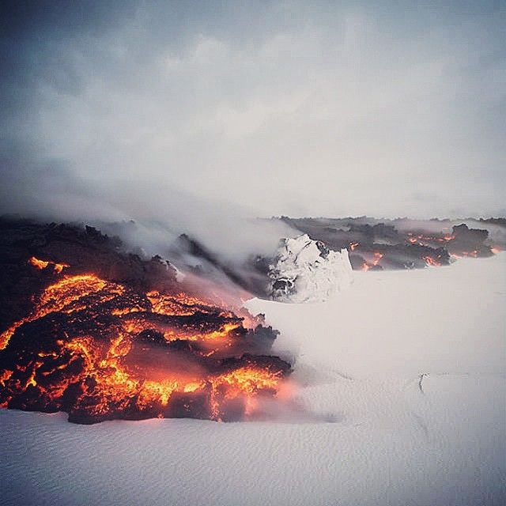
  - Mt Etna on the island of Sicily,
  - Stomboli on the island of Stromboli,
  - Vesuvius on mainland Italy near the Gulf of Naples which destroyed Pompeii
- Iceland is also home to many active volcanoes as is Russia

