|  |  |  |
| --- | --- | --- |
| Severn | 354km | Wales into England |
| Thames | 346km | England |
| Tay | 188km | Scotland |

Longest Rivers

* By area: Lough Neagh (Northern Ireland)
* By volume: Lough Ness (Scotland)

Largest Lakes

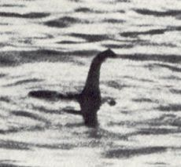

|  |  |  |  |
| --- | --- | --- | --- |
| England | Scafell Pike | 978m | Southern Fells |
| Wales | Snowdon | 1,085m | Cambrian s |
| Scotland | Ben Nevis | 1,344m | Grampians |

Highest Peaks

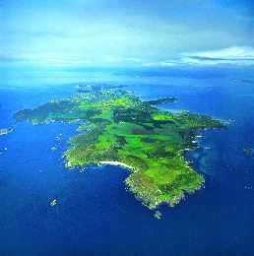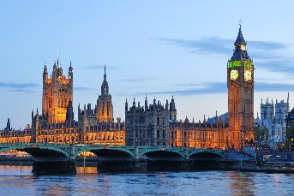

* Channel Islands
* Shetland Islands
* Outer Hebrides
* Orkney Islands
* Anglesey
* Firth of Clyde
* Falklands (South Atlantic Ocean)

Islands

|  |  |  |
| --- | --- | --- |
| Greater London* | 9.8m | England |
| Greater Manchester | 2.5m |
| West Midlands (Birmingham) | 2.4m |
| Greater Glasgow | 1.2m | Scotland |
| Edinburgh* | ~0.5m |
| Cardiff* | ~0.45m | Wales |
| Belfast* | ~0.6m | Northern Ireland |

*denotes capital city

Urban Areas & Cities

**Great Britain**

Points of Interest

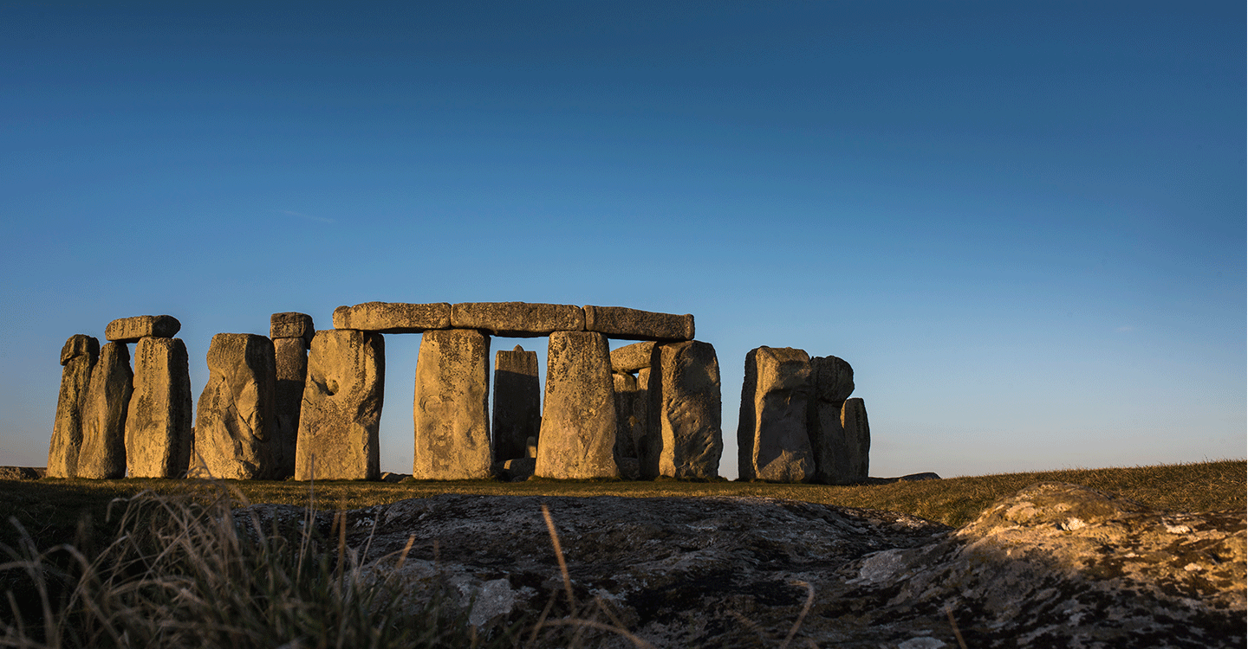Stonehenge

Angel of the North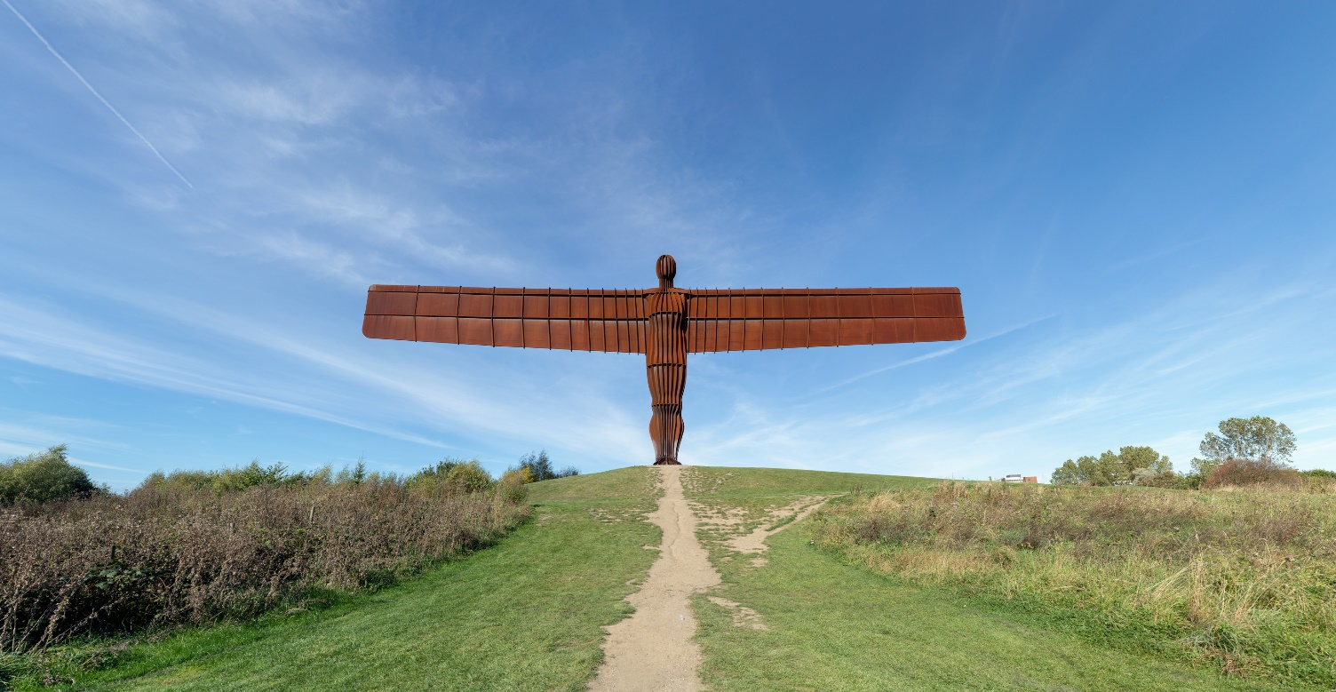

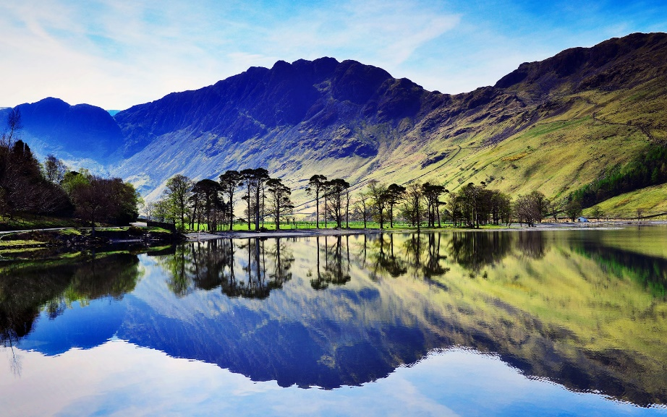Lake District

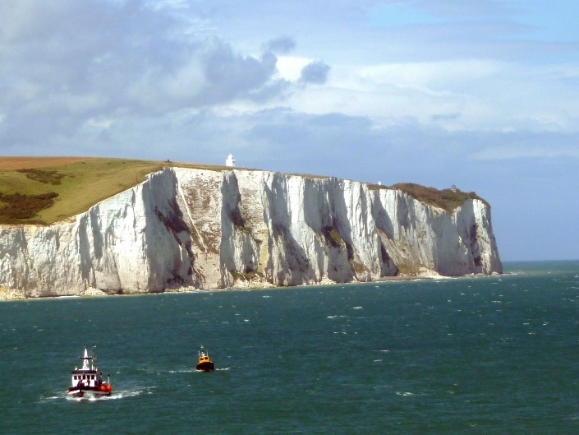Cliffs of Dover

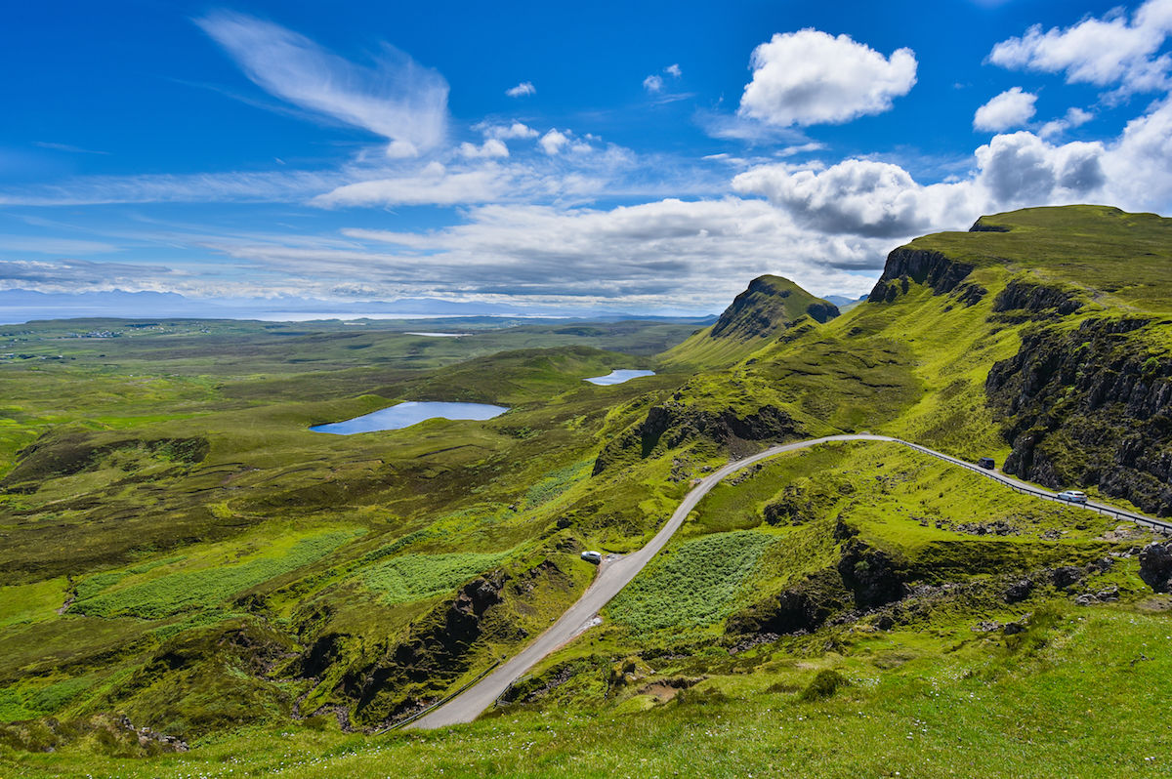Scottish Highlands