Child Protection Policy of St. Kevin’s GNS, Kilnamanagh

The Board of Management recognises that child protection and welfare considerations permeate all aspects of school life and must be reflected in all of the school’s policies, practices and activities.
Accordingly, in accordance with the requirements of the Department of Education and Skills’ Child Protection Procedures for Primary and Post Primary Schools, the Board of Management of Scoil Naomh Caoimhín has agreed the following child protection policy:

- The Board of Management has adopted and will implement fully and without modification the Department’s Child Protection Procedures for Primary and Post Primary Schools as part of this overall child protection policy.

- The school’s Designated Liaison Person (DLP) is Miriam Dignam and the school’s Deputy Designated Liaison Person (Deputy DLP) is Patricia Gallery.

- In its policies, practices and activities, St. Kevin’s GNS will adhere to the following principles of best practice in child protection and welfare:
The school will -
- recognise that the protection and welfare of children is of paramount importance, regardless of all other considerations;
  - fully co-operate with the relevant statutory authorities in relation to child protection and welfare matters;
  - adopt safe practices to minimise the possibility of harm or accidents happening to children and protect workers from the necessity to take unnecessary risks that may leave themselves open to accusations of abuse or neglect;
  - develop a practice of openness with parents and encourage parental involvement in the education of their children; and
  - fully respect confidentiality requirements in dealing with child protection matters.

- All school policies will reflect the tone and content of this policy. As policies, particularly those relevant to child protection, are revised and updated, their content will reflect this, and a list of such policies will be appended to this policy.
- The Board will ensure that the necessary policies, protocols or practices, as appropriate, are in place in respect of each of these items.
- This policy has been made available to school personnel and the Parents’ Association and is readily accessible to parents on request. A copy of this policy will be made available to the Department and the patron, if requested.
- This policy will be reviewed by the Board of Management once in every school year. The date of next review is December 2017.

This policy was originally adopted by the Board of Management on December 5th 2011. It was reviewed and ratified at a Board meeting on 5th September 2016.
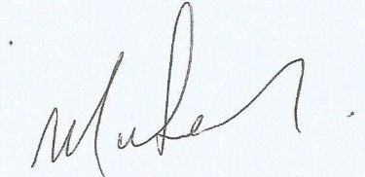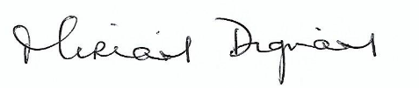
____________________________ __________________________
Chairperson of Board of Management Principal.

